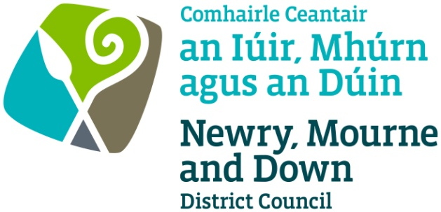

Newry, Mourne and Down District Council
Comhairle Ceantair an Iúir, Mhúrn agus an Dúin

PUBLIC NOTICE

Street Trading – Pride in Newry, Hill Street, Newry

Newry, Mourne and Down District Council on behalf of the organisers of Newry Pride are inviting applications for street trading at Hill Street, Newry, at the Pride in Newry event, 31 August 2024.

Applications for a Temporary Street Trading Licence will only be accepted from Monday 24 June 2024, 9:00am. Closing date for receipt of completed applications is Friday 5 July 2024, 4:00pm. Incomplete applications will not be accepted.

Street Trading Licences will be granted based upon the ‘criteria for the award of street trading licences’.

Please note there are a limited number of trading spaces available.

Please note the application fee is non-refundable regardless of whether your application for a Temporary Street Trading Licence is successful or not.

A Temporary Street Trading Application Form is available to download below.

The completed application form and relevant documentation should be returned to Newry, Mourne and Down District Council, Licensing Section, Economy, Regeneration and Tourism Department, Unit 19 Rampart Road, Greenbank Industrial Estate, Newry, BT34 2QU with a cheque or postal order, for the appropriate application fee, to be made payable to ‘Newry, Mourne and Down District Council’.

Email: licensing@nmandd.org

