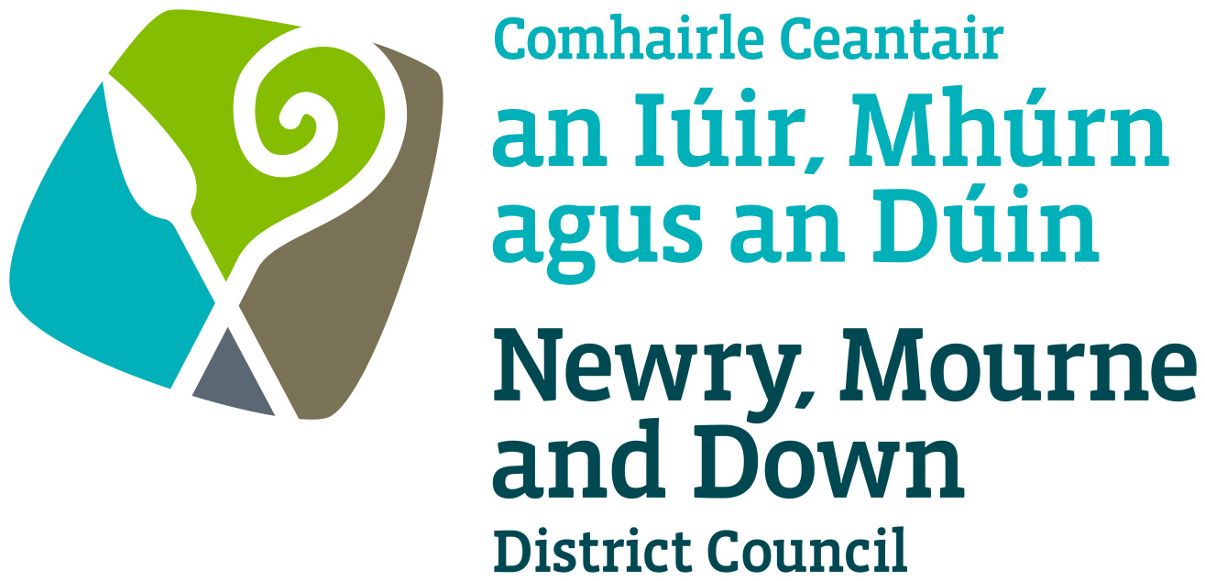

Gaming and Amusement Policy

Newry, Mourne and Down District Council

Economy, Regeneration and Tourism Department

Dated: 25 June 2024

The Betting, Gaming, Lotteries and Amusements (NI) Order 1985

STATEMENT OF POLICY
- Introduction

Newry Mourne and Down District Council, as the Licensing Authority (“the Authority”), makes this Statement of Policy (“the Statement”) in pursuance of its powers and duties under Section 349 of the THE BETTING, GAMING, LOTTERIES AND AMUSEMENTS (NI) ORDER 1985 (“the Order”) and sets out the Authority’s approach in dealing with its responsibilities under the Order.
- Aim and scope of policy - Why does the Council need an amusement permit policy?

The overall aim of the Gaming and Amusement policy is to serve as a guide for Elected Members, Council officers, applicants and the wider public in consideration of applications for, and the awarding of, amusement permits in the Newry Mourne and Down Council area. By outlining those matters which may be taken into account in determining the award of an amusement permit this policy has been developed to introduce greater clarity, transparency and consistency to the decision making process.
- The Key Objectives

The key objectives of this policy can be largely linked to the Council’s overarching strategic goal of improving the quality of life for present and future generations in the Newry Mourne and Down area by making it a better place in which to live, work, visit and invest. Against this background, the interrelated key policy objectives are to:
- promote the retail vibrancy and regeneration of Newry Mourne and Down;
- enhance the tourism and cultural appeal of Newry Mourne and Down by protecting its image and built heritage;
- support and safeguard residential communities in Newry Mourne and Down;
- protect children and vulnerable persons from being harmed or exploited by gambling;
- respect the need to prevent gambling from being a source of crime and disorder

- Location

The Council will objectively assess each application on its own merits. Five criteria will typically be used when assessing the suitability of a location for a proposed amusement arcade:
- Impact on the retail vitality and viability of Key Gateway Communities;
- Cumulative build-up of amusement arcades in key visitor destinations earmarked under the Corporate Tourism Strategy;
- Impact on the image and profile of Newry Mourne and Down;
- Proximity to residential use; and
- Proximity to schools, youth centres and residential institutions for vulnerable people.
- Application Criteria

While an application for an Amusement Permit in City/Town Centres will be assessed on its merits, it will only be granted in the retail core of City/Town Centre if it is:
- A renewal of an existing amusement permit; or
- Part of a major, retail-led mixed-use development; or
- An upper storey development: or
- A replacement for an existing amusement premises.
- Exclusions

In keeping with one of the key objectives of this policy, namely, to enhance the Tourism and Cultural appeal of Newry Mourne and Down by protecting its image and built heritage, the Council will not grant new amusement permits in town centres at City/Towns regarded as key visitor destinations (Gateways).
- Proximity to schools, youth centres and residential institutions for vulnerable people

The Council will not grant amusement permits in locations near* schools, youth centres and residential institutions for vulnerable people, including children’s care homes and hostels for the homeless.

*near shall be interpreted as not within 200m of such premises.

8. Related Policies

In carrying out the licensing function under the Order, the Authority will aim to permit the use of premises for gambling as long as it is considered to be: -
- In accordance with any relevant Guidance issued by the Department.
- In accordance with this Statement of Policy and
- Reasonably consistent with the licensing objectives

This Policy will come into force on the 02nd September 2024 and will be kept under review and revised or amended as required.

9. Policy Owner

Mr. Conor Mallon, Director of Economy, Regeneration and Tourism Department

10. Contact details in regard of this policy are:

Mr Jonathan McGilly
Assistant Director of Economy, Regeneration and Tourism
Newry, Mourne and Down District Council
O’Hagan House
Monaghan Row
Newry
BT35 8DJ

Telephone: 0330 137 4000

11. Policy Authorisation

Development Committee Meeting Authorised on 12 August 2024
Council Authorised on 02 September 2024

12. Policy Effective Date – 02nd September 2024

13. Policy Review Date – 02nd September 2028 (or sooner as required)

The policy will be reviewed in line with the Council’s agreed policy review cycle i.e. every 4 years (as per Council’s Equality Scheme commitment 4.31).

14. Equality Screening

This policy has been screened in accordance with the provision of Section 75 of the Northern Ireland Act 1998. The outcome of the equality screening is that the Gaming and Amusement Policy will not be subject to an equality impact assessment (with no mitigating measures required).

15. Rural Impact Assessment

The Policy has been subject to rural needs assessment.

Version 2.0

