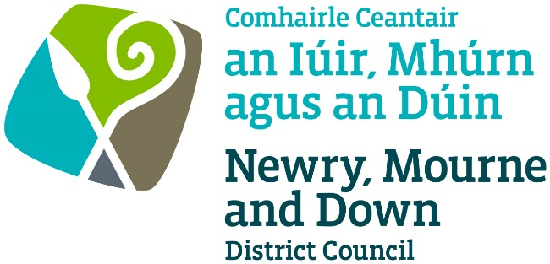

Licensing of Pavement Cafés Act
(Northern Ireland) 2014

APPLICATION FOR GRANT/RENEWAL/VARIATION OF A
PAVEMENT CAFÉ LICENCE

Completed Application to be sent to one of the below offices:

Oifig Dhún Padraig  Downpatrick Office  Licensing Section  Economy, Regeneration and Tourism  Department  Downshire Civic Centre  Downshire Estate  Ardglass Road  Downpatrick  BT30 6GQ | Oifig an Iúir  Newry Office  Licensing Section  Economy, Regeneration and Tourism  Department  Unit 19 Rampart Road  Greenbank Industrial Estate  Newry  BT34 2QU
For further information contact:
Tel: 0330 137 4030
Email: licensing@nmandd.org
www.newrymournedown.org

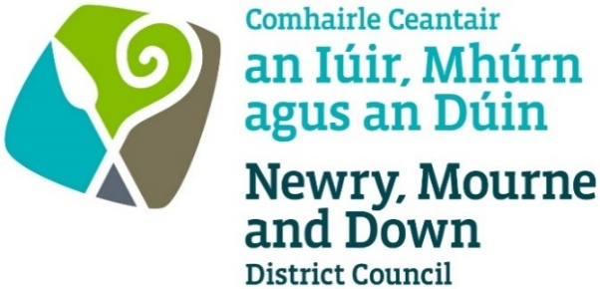

NMD Ref: _____

APPLICATION FOR LICENCE FOR

PAVEMENT CAFÉ

Licensing of Pavement Cafés Act (Northern Ireland) 2014

Section 1 of 6
I/We hereby make application to Newry, Mourne and Down District Council under the provisions of the Pavement Cafés Act (Northern Ireland) 2014 for the:

Application Type
Please ✓Tick appropriate box
☐ Application for Grant of a Pavement Café Licence
☐ Application for Renewal of a Pavement Café Licence
☐ Application for Variation of a Pavement Café Licence

Applicant Details

First name

Last name

Address

Postcode Date of Birth

Telephone number

Email

Designation: Owner/Director/Manager or otherwise state:

Section 2 of 6
Premises Details
Name of premises/trading name

Type of business

Address

Postcode

Section 3 of 6
Operating Details
Is alcohol to be consumed in the curtilage of the Pavement Café? ☐ Yes ☐ No
Are the premises licensed under the Licensing (NI) Order 1996? ☐ Yes ☐ No
Is the pavement café located directly outside the premises? ☐ Yes ☐ No
If remote from the premises, advise on location of pavement café:

[For remote pavement cafes, you must provide a management plan or risk assessment outlining how you intend to maintain control over the pavement café.]
Proposed days and hours of operation of the Pavement Café Area
Note: The hours applied for should reflect the normal operating hours of the business. In general, the operating hours of a pavement café will be limited to 11:00pm latest, to reduce potential noise disturbance during nighttime hours.
Days:  (tick all that apply) |  | Hours:
 |  | From: |  | To:
Monday

Tuesday
Wednesday
Thursday
Friday
Saturday
Sunday

Section 4 of 6
Proposal Details

Total width of footpath m
Is the area within 10 metres of a road junction? ☐ Yes ☐ No

Dimensions of café area: Length (m) x Depth (m)

Enclosure and furniture details

Number of tables and chairs: Tables and Chairs

Total number of umbrellas/parasols: Total number of space heaters:

Any other items to be provided in the enclosure:

Provide manufacturers details/advise on type, materials, number of all of above and include photograph.

Barrier/Screening Type: Height:

[The licensed area must have appropriate barriers/screening to make it distinguishable to other pavement users. Portable, sturdy barriers with a tap rail are recommended.]
Photographs of the proposed barriers and furniture included: ☐ Yes ☐ No

Section 5 of 6
Site Details (Refer to Pavement Cafés Guidance Document)

Provide an area Location Plan, Scale 1:1250, depicting location of Pavement Café marked in red and sufficient surrounding area with infrastructure.
☐ Here Enclosed ☐ To Follow

Provide a proposed Site Plan, scale not less than 1:100, depicting street space occupied, dimensions, size and type of barriers, number and type of tables and chairs, and any other pavement café furniture.
☐ Here Enclosed ☐ To Follow

Where will the Pavement Café furniture be stored when it is not in use? (Ensure furniture is stored remote from designated fire escapes.)

Section 6 of 6
Declaration and Signature

- I confirm that I wish to apply for a Pavement Café Licence for the development as described within this application.
- I confirm that that the information provided in this application is correct.
- I confirm that all furniture must be of a temporary nature that can be removed swiftly within 20 minutes at the end of the permitted period or when access to the area is required by any statutory body or in the event of an emergency.
- I confirm that I have placed the appropriate notice in a prominent place at or near the premises that it can easily be read by the public, and that the notice shall be displayed for 28-days from the date of this application.
- Information provided as part of this application may be disclosed in response to a request under the Freedom of Information Act 2000 or the Environmental Information Regulations 2004.
- Newry, Mourne and Down District Council collects data for the purposes of the management and application of the Pavement Café Act. The data may also be passed onto other related Government Agencies and to other Council Departments, to facilitate Statutory Requirements, Service Level Agreement of or similar purposes.
- Newry, Mourne and Down District Council collects the Data on this Form for the purpose of Administering Pavement Cafe Licensing under Licensing of Pavement Cafés Act (Northern Ireland) 2014.
- Newry, Mourne and Down District Council will consult with and share the data collected on this form with relevant Council Departments, the Police Service of NI and DfI Roads for the purposing of administering the licence under the Data Protection Act 1998.

The Council’s privacy notice can be accessed via our website www.newrymournedown.org/privacy-policy
☐ Ticking this box indicates that you have read and understood the above declaration.

 | Official Use Only
Print Full Name: | Date Received
Signature: | Receipt Number
Date: | £

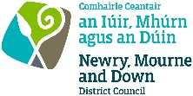
CHECKLIST

PAVEMENT CAFÉ LICENCE - I confirm I have enclosed the following:
Tick ✓

1. | Completed Application Form | ☐
2. | Confirmation from your Insurance Company that your premises has current valid Public Liability Insurance cover to a value of £5million. To include premises name, address and expiry date.  - Please note, Employer’s Liability Insurance is not acceptable - | ☐
3. | Location Plan (preferably Ordnance Survey) showing proposed pavement café marked in red and adjoining streets and properties. | ☐
4. | Site Plan to a scale of not less than 1:100, to include dimensions, show access points, building lines, boundaries, kerbs, table and chair arrangement, bins, lampposts, trees, and other items. | ☐
5. | Details of the Furniture to include the number, materials and types of chairs, tables, umbrellas to be provided in the café area together with photographs and/or manufacturers details of furniture. | ☐
6. | Signed copy of Public/Site Notice and photograph of notice displayed onsite. | ☐
7. | Fee  Card, cash or cheque payment accepted. Cheques to be made payable to: ‘Newry, Mourne and Down District Council’. | ☐
8. | Planning permission, if relevant. | ☐
9. | Risk Assessment and Management Control Plan if applicable. (Required if located away from main premises). | ☐

- Please see Guidance Notes for further information -

Licence Fee | Administration costs  (Non-refundable) | Compliance monitoring  (2 visits) | Actual cost  for 3-year licence
Grant of  Pavement Café Licence | £300 | £100 | £400 Total
Renewal or Variation of Pavement Café Licence | £200 | £100 | £300 Total
All documentation may be emailed to: licensing@nmandd.org
(as MS Word, pdf attachments (or jpeg format for photos)).
We may ask for the original of any scanned or emailed document.

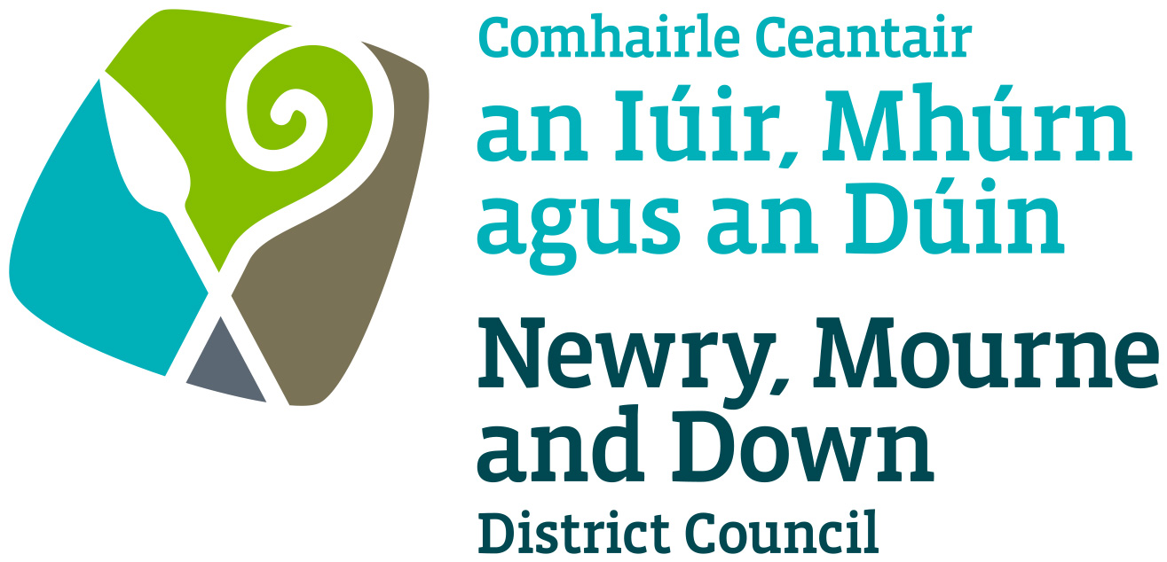

NEWRY, MOURNE AND DOWN DISTRICT COUNCIL

Licensing of Pavement Cafes Act (Northern Ireland) 2014

PUBLIC NOTICE

APPLICATION FOR A PAVEMENT CAFÉ LICENCE

NOTICE IS HEREBY GIVEN THAT

Name of Applicant:
has applied to Newry, Mourne and Down District Council for a Pavement Café Licence at
Name and address of premises:
Any objection relating to the application must be made in writing and must specify the grounds of the objection, the name and address of the person making it and must be signed by them or their agent. Any objection should also be made within 28 days of the date of this Notice (below).
The objection should be addressed to Newry, Mourne and Down District Council, Licensing Section, Economy, Regeneration and Tourism Department, Unit 19 Rampart Road, Greenbank Industrial Estate, Newry, BT34 2QU or Licensing Section, Economy, Regeneration and Tourism Department, Downshire Civic Centre, Downshire Estate, Ardglass Road, Downpatrick, BT30 6GQ. Email: licensing@nmandd.org

It should be noted that where an objection is made after the 28-day time period referred to, but before a final decision is taken on the application, it is appropriate for the Council to consider it if there is sufficient reason why the objection was not made within the stated time period.

Applicant’s Signature: |  | Date:

This site notice must be displayed for the whole of the period of 28 days
in a prominent place at or near the premises so that it can be conveniently read by the public.

